The Centre
@ Mary’s Place



8 Burton St
Melton Mowbray
Leics
LE13 1AE

01664 503521
073 9426 9700

email: manager@marysplace.org.uk

Website: www.marysplace.org.uk

‘Rooms for all occasions in the centre of Melton Mowbray’

Room Hire Information
 2025

The Centre
@ Mary’s Place

Situated in the heart of Melton Mowbray, Mary’s Place is a superb resource for the whole community.

With four flexible rooms and open 7 days a week, the centre can accommodate any function:
- Conferences / Meetings / Recruitment/ Interviews
- Business meetings
- Social Clubs
- Counselling
- Fitness Clubs
- Christenings
- Funerals / wakes
- Children’s Parties
- Family Celebrations

- We have rooms available for all your requirements

The Centre @ Mary’s Place has a lift for easy access to all our upstairs rooms.

For all enquiries please contact Linda Abbott, Centre Manager on:-
01664 503521 / 073 9426 9700 or by email manager@marysplace.org.uk
Website: www.marysplace.org.uk
or pop into the centre and speak to me, I usually work Monday – Thursday mornings, ask the receptionist to let me know you wish to speak to me or ring 073 9426 9700 on arrival.

The Centre
@ Mary’s Place

The Rooms
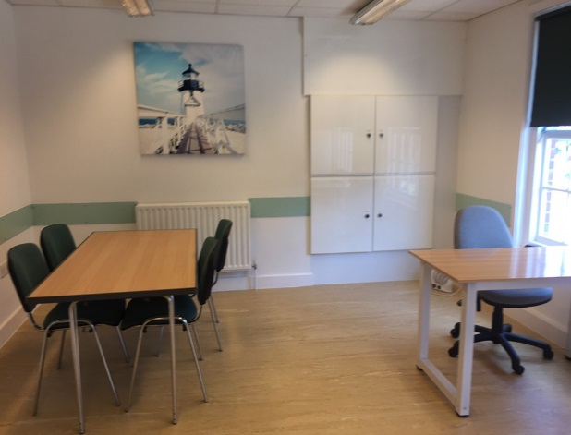
Currently available only for evening bookings
Room 1
A room ideal for counsellors or small groups. It has been freshly renovated & is a cool, modern space.

Rooms 2 & 3

Rooms 2 and 3 are one large room holding up to 70guests for a sit down meal, or 100 people for a conference. The room can also be separated by the partition wall which creates two smaller rooms, holding up to 50 people.

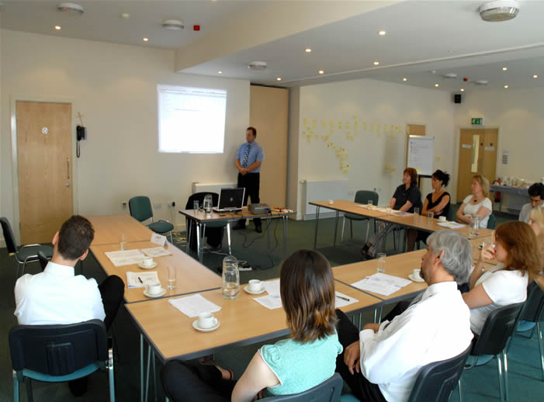

Room 4
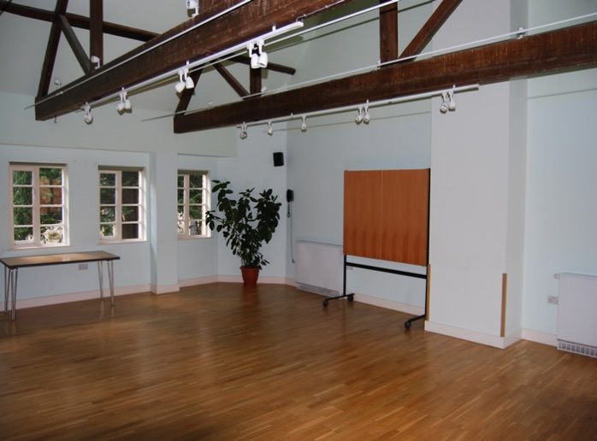Room 4
This room can accommodate 40 – 50 people, it has a mirrored wall ideal for a dance / fitness class. The hardwood floor also makes it an ideal easy to clean space for crafts, artwork etc.

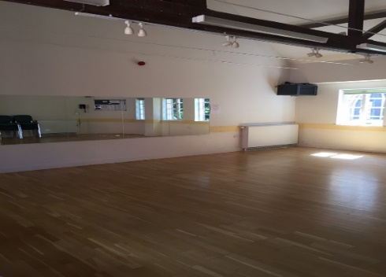

If you wish to make a booking please complete the Booking Form in this pack & return to us, once this has been received please await confirmation. We are able to ‘pencil in’ / reserve a particular date, but this cannot be confirmed until the completed Booking Form is received.

The Centre
@ Mary’s Place

Room Hire Charges
Room | Max capacity | Rate A |  | Rate B
Room 1 | 10 | £12.00 per hr. |  | £20.00
Room 2 | 50 | £12.00 per hr. |  | £20.00
Room 3 | 40 - 50 | £12.00 per hr. |  | £20.00
Room 4 | 40 - 50 | £12.00 per hr. |  | £20.00
Rooms 2 & 3 | 100 | £24.00 per hr. |  | £40.00

Rooms are let on an hourly basis, minimum of 2 hours per month.

Room hire charges apply from start of set up to the end of the event.

Rate A For charity groups / regular weekly users

Rate B For business users
Extra Facilities Available
Flip Chart/White board paper and pens £5.00 per session
For buffets and refreshments we may be able to cater for your function using an outside caterer, or you may arrange your own outside catering. We also have a Kitchenette available, this must be left clean and tidy, and all rubbish removed after your function.

 The Centre @ Mary’s Place
8 Burton Street, Melton Mowbray, Leics LE13 1AE
Tel: 01664 503521 email: manager@marysplace.org.uk

BOOKING FORM
2025

Hirer details (name of person responsible): ……………………………………………………………………………………

What is the room going to be used for? …………………………………………………………………………………………….

Room required: Room 1 / Room 2 / Room 3 / Room 4 / Rooms 2 & 3

Date you wish to book or if regular booking date commencing:-
Day: ……………….…………… Date: ……………… . Month: …………………………………….. Year: 2024
Time: from: …………a.m. ……………… p.m. To: ………………a.m. …………… p.m.

Please feel free to set up room as required, but clear away afterwards, this time must be included in hire time.
Flip Chart & pens (£5.00 charge) YES / NO
Do you require use of the kitchenette? YES / NO
Do you require us to provide refreshments: YES / NO (if yes please complete below) (self serve)
Tea, coffee & biscuits @ £1.75 p.p. per serving at (time/s) ……….a.m. ………. p.m. for: ………. people

For completion & return, confirmation will then be sent to you..
FOBS ARE ONLY NEEDED FOR OUT OF HOURS ACCESS.
Our Caretaker will open / lock up & alarm the building.
Please give the name/s of people in your group who have a fob: ……………………………………………………..
OR If you need a fob name of responsible person to collect: ……………………………………………………………

DAILY / WEEKLY / MONTHLY / FORTNIGHTLY / OTHER please give details.
Minimum of 2 hours per month
DATE | MON | TUES | WEDS | THURS | FRI | SAT | SUN | RATE  Per hour
Contact details of the responsible hirer (over 18) & details of where invoice to be sent to: -
Name: …………………………………………………………………... Address …………………………………………………: ……………………………………………………….…………………………… Postcode: ………………………………………………
Home tel number: …………………………………………………. Mobile number: …………………………………………
email address: ………………………………………………………. Signed: ………………………………………………………
Invoices will be emailed out at the end of each month.
If the invoice is NOT to be sent to the above named please give details below:-

Name: …………………………………………………..… email: ……………………………………………………………………
(Please write clearly)
LA / Aaaa BOOKING FORM MARYS PLACE 2025

The Centre @ Mary’s Place

8 Burton Street, Melton Mowbray, Leics LE13 1AE
Tel: 01664 503521 email: manager@marysplace.org.uk

Conditions of Hire

The term Hirer, denotes the person or organisation representative that made a booking to hire room(s) or other parts of Mary’s Place, whilst the terms booking, session, period of hire or arrangements indicate the booking period made by the Hirer.

The hiring of certain areas of Mary’s Place is accepted as long as the hirer agrees to the following terms and conditions out below.

The Hirer shall book the required session within the available time slots and indicate any additional requirements that may be needed during the period of hire, for example, refreshments, presentation equipment etc.
The Hirer shall, during the period of hiring be responsible for the supervision of the premises, protection of the fabric and content, safety from damage however slight, or change of any sort and the behaviour of all persons using the premises whatever their capacity.
The Hirer shall be responsible for obtaining any licenses necessary in connection with the booking other than already held by Mary’s Place. Please note that Mary’s Place does not have an alcohol or music licence.
The Hirer shall be responsible for arranging insurance against any third-party claims which may lie against the Hirer whilst using Mary’s Place. Mary’s Place is insured against any claims arising out of its own negligence. If window restrictors are removed this then becomes the responsibility of that person / group.
The Hirer shall be responsible for the observance of all regulations appertaining to the premises stipulated by the Licensing Justices, the Fire Authority in accordance with rule 4, and the Local Authority or otherwise.
The Hirer shall not sub-let or use the premises for any unlawful purpose or in any unlawful way nor to do anything or to bring onto the premises anything which may endanger the premises, their users or any insurance policies relating thereto. Mary’s Place reserves the right to decline / cancel any booking that does not comply with our Constitution.
The Hirer shall indemnify Mary’s Place for the cost of repairing of any damage done to any part of the property including the surrounding grounds or the contents of the building during or as a subsequent result of a booking, however caused. Moving the partition wall in Rooms 2 & 3 is restricted to authorised staff only, Mary’s Place shall not be liable for any personal injuries by unauthorised persons & if damage is caused the cost to repair will be claimed from the persons responsible.
The Hirer shall give at least 2 weeks’ notice of cancellation to Mary’s Place. If a cancellation is made in the 1 week prior to the booking date, then we reserve the right to charge for the room hire unless Mary’s Place can re-book the same room(s). Mary’s Place reserves the right to cancel long term bookings with a minimum of 4 weeks’ notice if the room is no longer available to rent.
The Hirer shall be allowed to move the furniture of the booked room(s) but must ensure it is returned to its original position at the end of the session. If this is not adhered to then we reserve the right to make a charge.
The Hirer shall undertake to ensure the safety of all people attending Mary’s Place in respect of the booking, by maintaining an attendance register and bringing to the attention of the group, the fire and safety procedures which are located at the top of both front and back staircases.
The Hirer shall, if using the kitchen facility, be responsible for the washing, drying and putting away any crockery/ cutlery used during the session and clears up all waste/ litter/ rubbish left and disposes of independently. All rooms to be left in a clean & tidy condition ready for the next user, including any breakages & clearing up of any spillages made onto carpeted areas, we reserve the right to make a charge for any damage.
The Hirer shall ensure all sessions are completed by the time agreed at booking.
The Hirer shall, if the booking is made for a period outside of normal office hours of Mary’s Place, request or be offered a premises fob which must be collected during normal office hours of Monday to Friday 9.00am to 3.00pm. Fobs are not available outside these hours.
The Hirer shall be responsible for the return of any loaned premises fob as soon as it is no longer required. (Hirers can post fob through letterbox on vacating the building if used for single booking only). £20 charge if not returned.
The Hirer can bring their own equipment provided that it is not dangerous, hazardous or illegal. We accept no liability for equipment bought into the building and would ask you to comply with the rules set out in the Health and Safety at Work Act.
The Hirer shall reimburse Mary’s Place in line with their current charges should any of the terms 7, 8,9,11,12,13,14 & listed above, not be adhered to.
Mary’s Place has public liability (third party) insurance which provides an indemnity as property owners if held legally liable for accidental bodily injury to members of the public, or accidental damage to their property whilst the premises are being hired. This insurance, however, doesn’t extend to indemnify any outside groups hiring the premises.
You are advised that our terms and conditions make the hirer responsible to indemnify Mary’s Place for any injury or damage occurring at the premises, other than where Mary’s Place is legally liable.
Mary’s Place reserves the right to move a booking either one-off or regular to another room of a similar size, with a
minimum of four weeks’ notice. If this is unacceptable to the hirer, they may cancel their booking forthwith.
Any complaints should in the first instance be made to the Centre Manager.

The Centre
@ Mary’s Place

The Team Parish of Melton Mowbray
Safeguarding provisions for the hire of its premises

The Parochial Church Council of the Team Parish of Melton Mowbray has a Policy for Safeguarding Children, Young People and Vulnerable Adults. A copy can be found at: St. Mary's C of E Parish Church : St. Mary's C of E Parish Church (anglican.org) . Your booking agreement is conditional upon you complying with it unless you already have an equivalent policy of your own.
You are required to ensure that children, young people and vulnerable adults are protected at all times, by taking all reasonable steps to prevent injury, illness, loss or damage occurring; and that you carry full liability insurance for this.
In particular this means that:
• you will comply with the Parish Safeguarding Handbook St. Mary's C of E Parish Church : St. Mary's C of E Parish Church (anglican.org) unless you already have an equivalent;
• you will provide the church with a copy of your organisation’s Safeguarding Policy or, if you do not have one, you must adopt the current parish policy;
• you will recruit safely all current paid and voluntary workers who work with children and/or vulnerable adults, by obtaining satisfactory disclosures from the Disclosure and Barring Service where eligible, and keeping records of dates and disclosure numbers indefinitely;
• you will keep a list of the names of all paid and voluntary workers with regular and direct contact with children/vulnerable adults, and update it annually;
• you will always have at least two leaders over the age of 18 years in any group of children and young people, no matter how small the group;
• no person under the age of 18 years will be left in charge of any children or young people of any age;

Cont/…….

• no child or group of children or young people should be left unattended at any time;
• a register of children, young people or vulnerable adults attending the activity will be kept securely. This will include details of their name, contact details of parent/guardian/carer etc., date of birth and next of kin;
• you will immediately (within 24 hours) inform the Parish Safeguarding Officer of:
(a) the occurrence of any incidents or allegations of abuse or causes of concern relating to members or leaders of your organisation, and contact details for the person in your organisation who is dealing with it
(b) any known offenders against children or vulnerable adults seeking to join your membership, and manage any allegations or agreements with offenders in co-operation with statutory agencies, and with the church.

The Parish Safeguarding Officer for the Team Parish of Melton Mowbray is:
Name: Roger Kirby
E-mail: rogkirby@hotmail.com Tel. No: 07550013760

Declaration:
I agree to abide by appropriate safeguarding procedures. I understand that my booking agreement may be terminated in the event of my failing to comply with these procedures.

Signed …………………………………………………

Designation ……………………………

Organisation …………………………………………..

Date ……………………………………

Please sign two copies, one to be retained by the church/ The Centre @ Mary’s Place, and one by the organisation

The Centre @ Mary’s Place

Constitution - The Centre @ Mary’s Place
Melton Mowbray PCC

1. NAME
The name of the building will be The Centre @ ‘Mary’s Place’ (previously known as the Samworth Centre@St Mary’s prior to September 2019).

2. AIMS & PURPOSES
a) To provide and manage a place of meeting for a wide variety of community groups and activities from Melton Mowbray and the surrounding area.

b) To provide office accommodation for the Melton Mowbray Team Parish Administrator and staff.

c) To identify and facilitate programmes of activity which will benefit the local community, including those excluded or disadvantaged through disability or other factors.

d) To operate in partnership with Melton Mowbray Team Parish Parochial Church Council (hereafter termed the PCC).

3. LETTINGS & BOOKINGS POLICY

a) The Manager of Mary’s Place will be responsible for drawing up lettings and booking agreements for all users of the building, which shall include the following provisions:

b) In accordance with the trusts on which Mary’s Place is owned, and which are that it must be used for ecclesiastical purposes within the Parish of Melton Mowbray In accordance with its Christian beliefs and principles, the PCC, through the Management Group, will not be able to approve bookings which allow non-Christian worship or clearly inappropriate activities to take place on its premises.

c) All regular bookings will include a clause which will allow the Manager of Mary’s Place discretion to make occasional alterations to the booking to facilitate special events in Mary’s Place, subject to reasonable notice being given.

d) The Manager of Mary’s Place, on behalf of the PCC, is responsible for bookings but in case of any concerns will refer the query to the Management Group.

e) The Management Group reserves the right to cancel/stop a booking that is considered inappropriate.

f) The letting and booking arrangements should be in line with the Church of England Presence & Engagement task group document viz. ‘Presence & Engagement Guidelines: Use of Church Halls,’ with particular reference to the section ‘Considerations in responding to requests’.

LA/BOOKINGS /CONSTITUTION

